

**PPP**

**Projet Professionnel Personnel**

Prepared by:

* Fnouni Rabeb
* Zribi Ghofrane

**Supervised by : Mme Afef Slama**

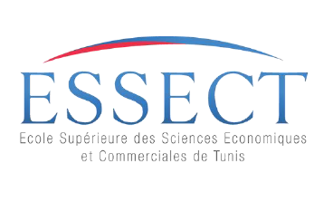

2024/2025

Table of Contents

2 . Introduction to the Subject : 3

3 . CVs : 5

4 .motivational letter : 6

5 forum results : 7

6 . professional project : 12

7 .Conclusion : 12

2. Introduction to the Subject

A Personal Professional Project (PPP) is a focused initiative undertaken by an individual to develop skills, enhance their career, or achieve specific professional objectives.

Such a project is typically pursued beyond the scope of regular job responsibilities and aims to provide long-term personal or professional benefits.

In this report, I will present the key components of this subject, including:

The CV

Cover Letter

Results from Digital Marketing Research

Professional Project

3 . CVs : 5

# 

4 .motivational letter : 5forum results : 7

Zribi Ghofrane Fnouni Rabeb ghofranezribi493@gmail.com fnounirabeb07@gmail.com

**Dear Hiring Manager,**

We are excited to apply for the Digital Marketing Intern position at Ecomness. As second-year Business Computing students specializing in E-Business at ESSEC Tunis, we are eager to bring our skills in content creation, web development, and social media management to contribute to your innovative team.

Our academic background has equipped us with a solid foundation in programming languages such as HTML, CSS, JavaScript, and Oracle SQL, which we have complemented with coursework in digital marketing. Additionally, our experience in creating compelling content for various platforms has fueled our passion for crafting engaging advertising materials, aligning perfectly with the responsibilities outlined for this role.

We are particularly drawn to Ecomness’ emphasis on creativity and its commitment to developing impactful product advertising. Joining your team would provide us with an invaluable opportunity to learn from industry professionals, refine our marketing skills, and actively contribute to the success of your product launches.

Looking ahead, we aspire to pursue a Master’s degree in Digital Marketing and establish our own agency specializing in content creation and social media management. This internship is a critical step in achieving our goals and an opportunity to bring our creativity, discipline, and problem-solving abilities to Ecomness.

Thank you for considering our application. We look forward to the opportunity to **discuss how our skills and ambitions align with the goals of your team.**

**Yours truly**

**Ghofrane zribi , Rabeb Fnouni**

**Ecomness | Business Consulting and Services | Ezzahra, Ben Arous, Tunisia**

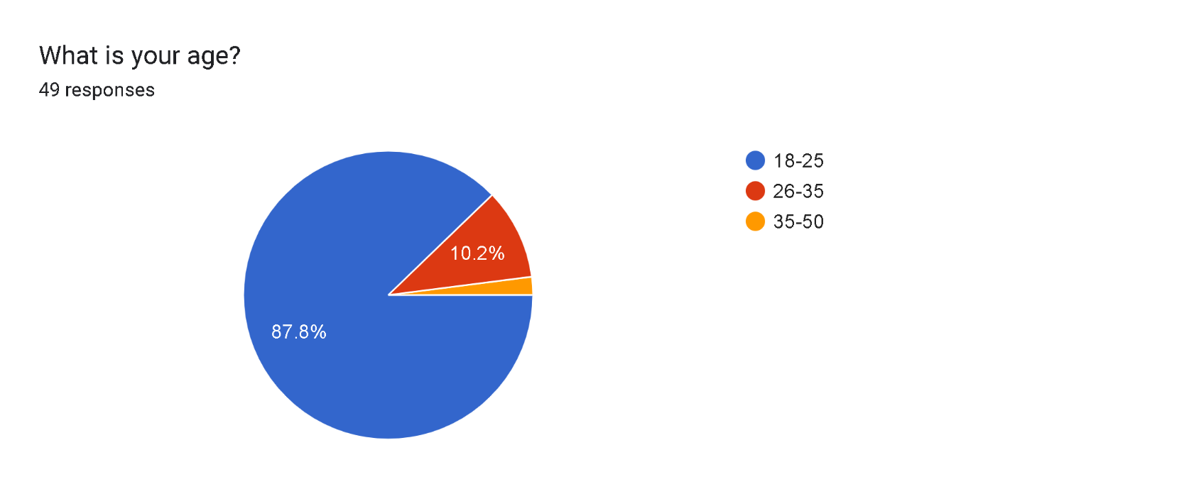**Results from Digital Marketing Research**

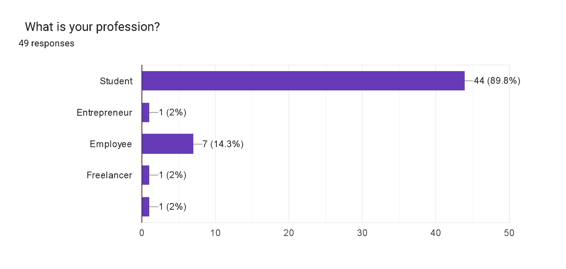

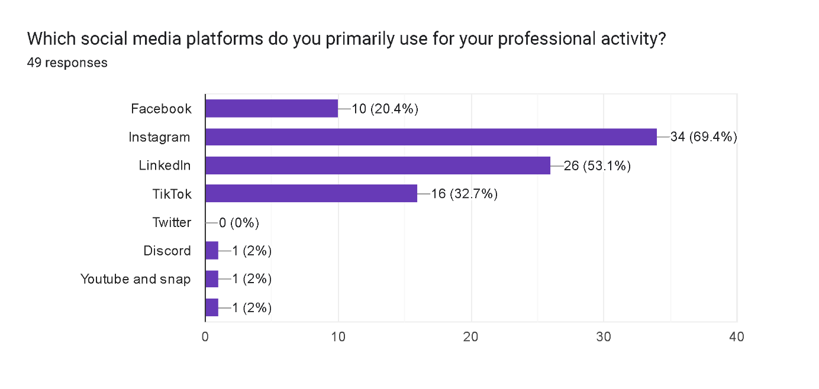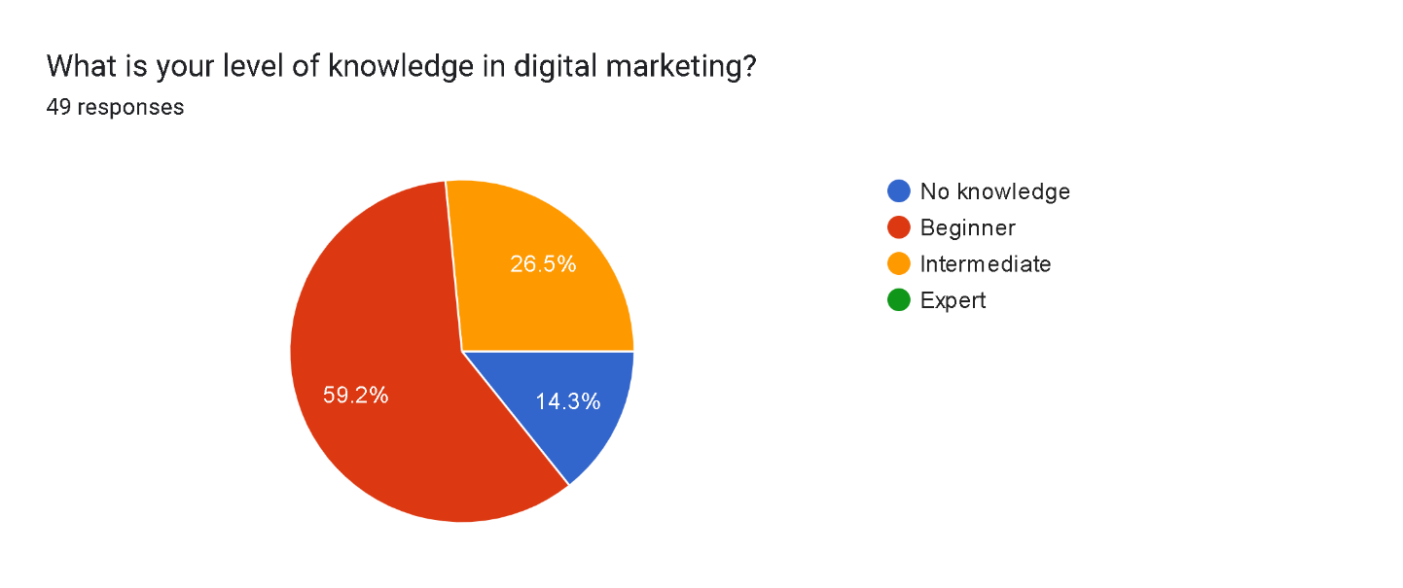

# Forms response chart. Question title: Which digital marketing services interest you the most? (select all that apply)  . Number of responses: 49 responses.



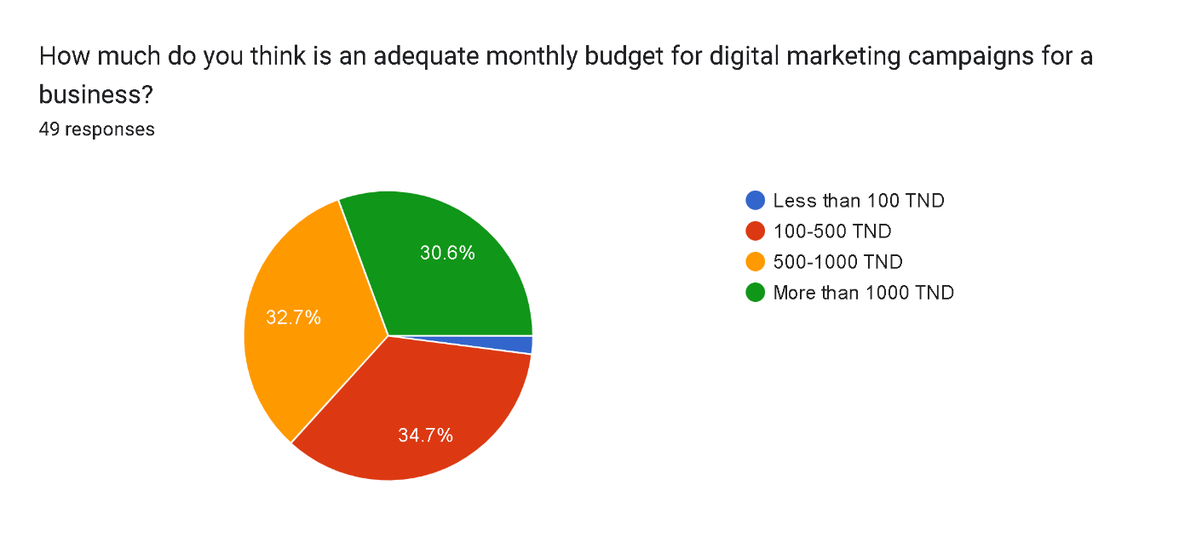

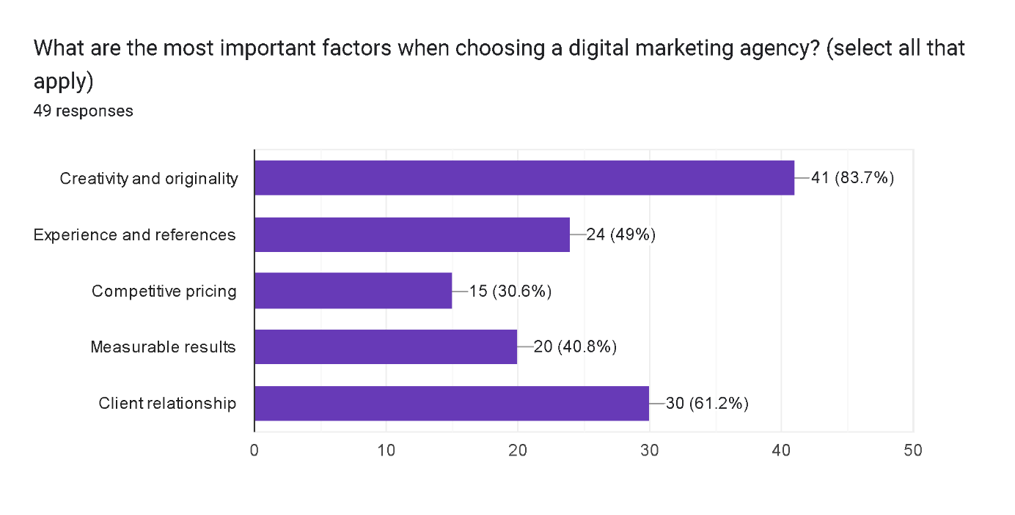

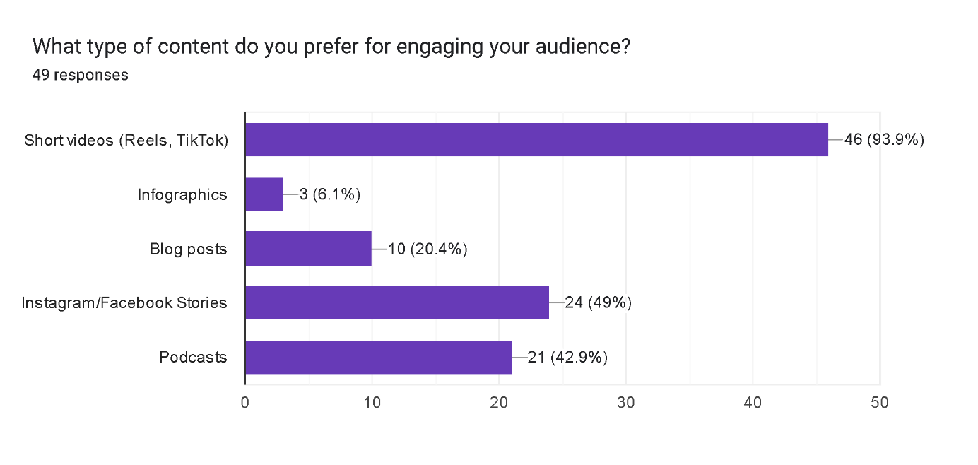

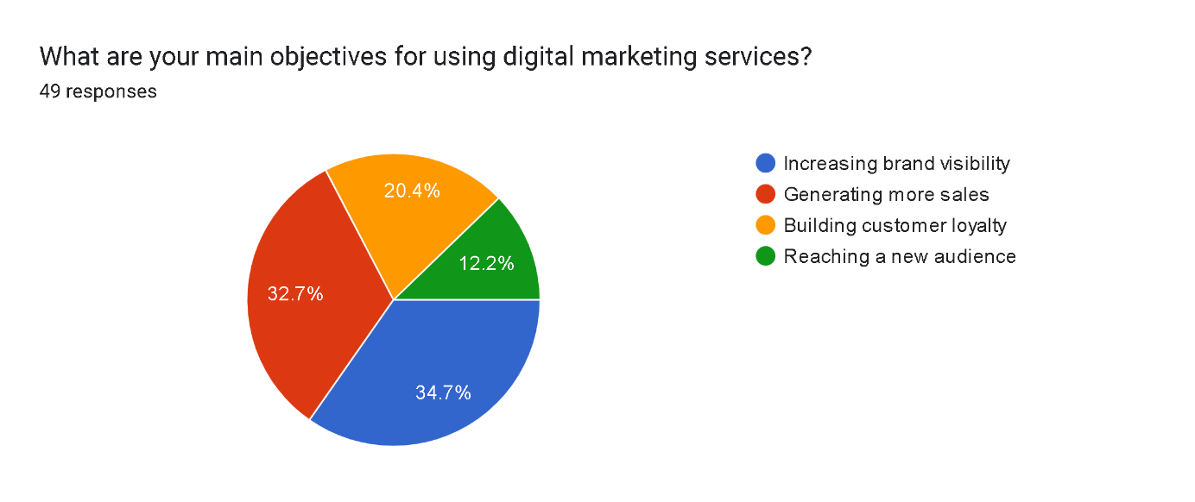

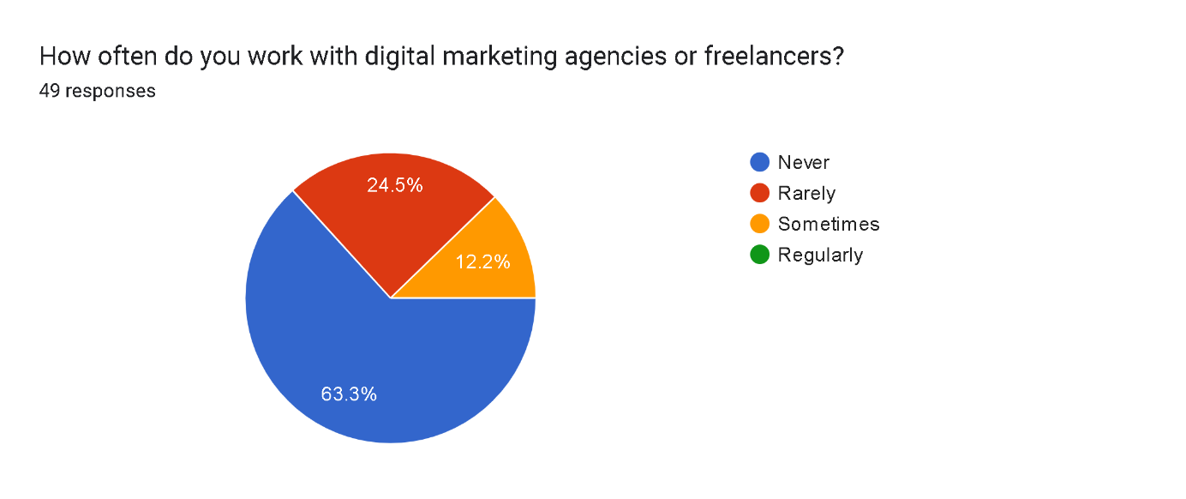

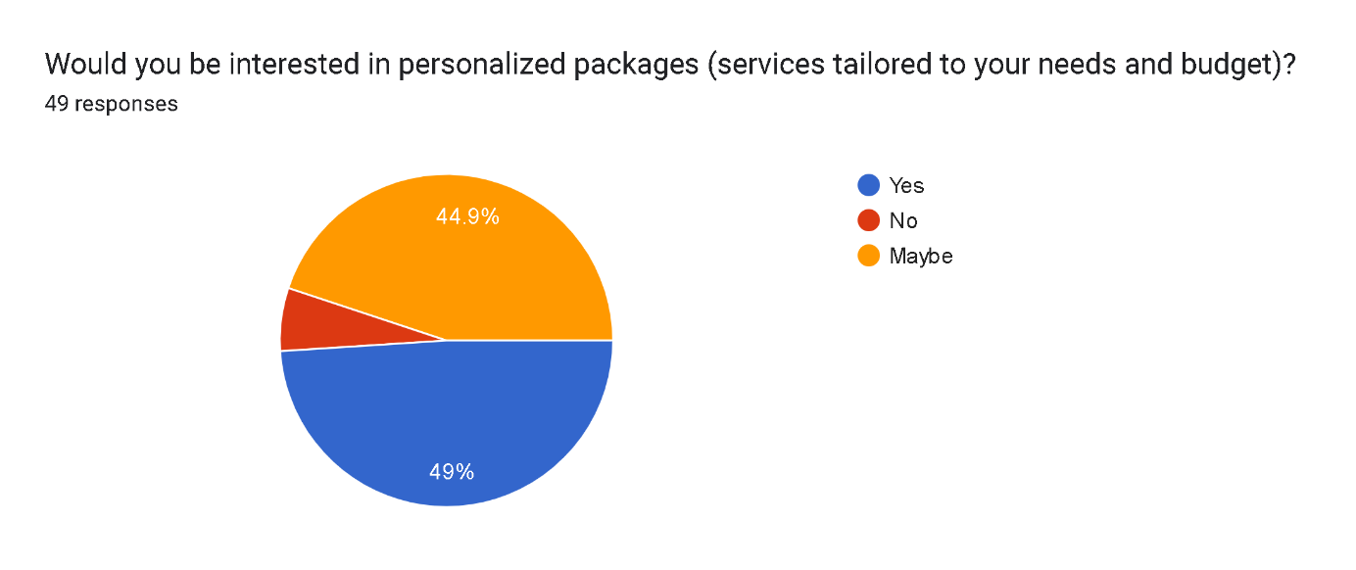

**What do you expect from a digital marketing agency to stand out? 14 responses:**

* Bright idea to sell the product what ever it is .
* Data-Driven Approach
* Creativity
* Come up with original ideas
* Her capabilities in attracting newcomers
* Driving measurable results through innovative strategies, creative solutions, and a deep understanding of your business. We focus on building long-term partnerships, leveraging data and insights to deliver personalized, high-impact digital marketing campaigns that elevate your brand and maximize ROI
* Prepare a marketing strategy,Provide frequent updates, Share awareness of trends, best practices, and technologies
* Achieve business objetives correctly in a short time
* Uniqueness
* Being Unique and Outstanding
* A digital marketing agency should deliver real results by increasing sales, leads, or traffic while staying creative and using unique ideas to grab attention. It must understand the target audience, ensuring campaigns reach the right people effectively. Clear communication and regular, easy-to-understand reports are essential to keep clients informed. Finally, staying updated with the latest tools and trends helps the agency remain competitive and innovative.

6 . professional project : 12

**Introduction**

We are Ghofrane Zribi and Rabeb Fnouni, second-year Business Computing students at ESSEC Tunis, specializing in E-Business. United by our shared passion for creativity, technology, and strategic planning, we have crafted a professional project focusing on digital marketing. This project outlines our unique strengths, academic backgrounds, professional experiences, and aspirations to establish a successful career and, ultimately, a digital marketing agency.

**1. Our Qualities  
Creativity (Rabeb):**Rabeb has a natural talent for generating innovative ideas, particularly in content creation and marketing campaigns. She excels at conceptualizing social media strategies and producing visually appealing content. For example, she successfully developed and implemented creative marketing strategies during academic projects. After attending several webinars on digital marketing, Rabeb was inspired to pursue a career in this field, realizing how creativity can make a lasting impact in the digital world.

**Analytical Skills (Ghofrane):**Ghofrane brings a strong analytical mindset, excelling in interpreting data and adjusting strategies based on performance metrics. With a deep understanding of programming languages and technical tools, she approaches digital marketing with a data-driven focus. Her background in computer science allows her to combine technical skills with marketing strategies, ensuring that campaigns are not only creative but also effective and measurable. Ghofrane has always wanted to pursue a creative career, but her passion for technology motivates her to blend creativity with the technical aspects of digital marketing.

**Together, we complement each other**—Rabeb brings creativity and innovation, while Ghofrane offers technical analysis and data-driven insights. This partnership allows us to approach projects from multiple angles, ensuring that our solutions are both creative and grounded in real-world performance.

**Autonomy:**Both of us excel at working independently and managing tasks efficiently. This is evident in our ability to balance academic work with extracurricular activities and personal projects.

**Adaptability:**We both quickly adapt to new tools and environments. Our experience learning and applying various programming languages and marketing platforms highlights this skill.

**Communication:**We are both skilled communicators, able to articulate ideas clearly and collaborate effectively in team settings. Our ability to express complex concepts has been key to our success in group projects and presentations.

**2. Our Weaknesses  
Impatience (Rabeb):**Sometimes, Rabeb expects quick results, particularly when working on creative projects. However, she is learning to focus more on the process and recognize the value in taking time to refine her work to achieve better outcomes.

**Stress Management (Ghofrane):**While Ghofrane thrives under pressure, she occasionally lets stress affect her decision-making. She is actively working on improving this by implementing better time management techniques and self-care routines.

**3. Our Background and Experiences  
3.1 Our Background**We are both pursuing degrees in Business Computing, which has given us a strong foundation in programming, problem-solving, and business operations. Our coursework has introduced us to essential digital tools used in marketing, such as analytics platforms, social media management tools, and content creation software.

**3.2 Our Experiences**

* **Rabeb (Creative Focus):**
  + Participated in academic projects focusing on digital strategy and content creation.
  + Self-studied marketing trends, content creation, and campaign planning, with a particular focus on social media strategies.
  + Attended several webinars on digital marketing, which deepened her desire to pursue a career where creativity and marketing intersect.
* **Ghofrane (Analytical Focus):**
  + Gained hands-on experience in web development and digital strategy, applying technical skills to solve marketing challenges.
  + Managed online content and analytics for a community service organization, utilizing data to improve engagement and content reach.
  + Focused on combining her knowledge of computer science with digital marketing tools to create data-driven campaigns.

These experiences have helped us understand the real-world application of digital marketing techniques and how they can be enhanced with both creativity and technical analysis.

**4. What We Want to Do**We both aim to establish careers in digital marketing, focusing on content creation and social media management for brands. **Rabeb** wants to bring creativity and innovative ideas to the table, while **Ghofrane** seeks to implement technical and analytical skills to ensure that marketing strategies are both engaging and measurable. Together, we aspire to build a digital marketing agency that merges creativity with data to create compelling and results-driven campaigns.

**5. What We Know and Can Do**

* **Rabeb (Creative Skills):**
  + Skilled in social media management tools like Meta Business Suite and content creation platforms.
  + Proficient in crafting engaging posts, designing visuals, and optimizing social media engagement.
  + Strong creative writing and graphic design skills to craft visually appealing content.
* **Ghofrane (Analytical Skills):**
  + Experienced in using analytics tools like Google Analytics and data visualization software.
  + Proficient in programming languages (Java, PHP, HTML/CSS) that support website development and digital marketing strategies.
  + Strong analytical and problem-solving skills, capable of optimizing campaigns based on performance metrics.

**6. Where We See Ourselves  
In 5 Years**We see ourselves running a successful digital marketing agency that specializes in social media management, content creation, and data-driven marketing strategies. Our agency will focus on innovation, quality, and customer satisfaction, with a dynamic team collaborating to achieve clients' goals.

**In 10 Years**We aim to expand our agency internationally, exploring new opportunities in branding, digital transformation consulting, and marketing automation. By this time, we will have earned master’s degrees in Digital Marketing, further developing our expertise to make our agency a leader in the industry.

**7. Our Professional Project  
7.1 Careers That Interest Us**We are particularly interested in roles such as:

* Digital Marketing Manager
* Social Media Strategist
* Content Creator

These positions align with our combined interests in creativity, technology, and marketing.

**7.2 Engaging with Professionals**We have attended webinars, read industry blogs, and networked with professionals in digital marketing. These interactions have provided us with valuable insights into the industry's challenges and opportunities, confirming our passion for this field and the importance of staying up-to-date with trends.

.Conclusion : 12

This professional project embodies our shared vision to transform the digital marketing landscape by combining creativity, technology, and strategic thinking. Together, we aim to build a successful agency, continuously learning and growing to make a meaningful impact in the industry.